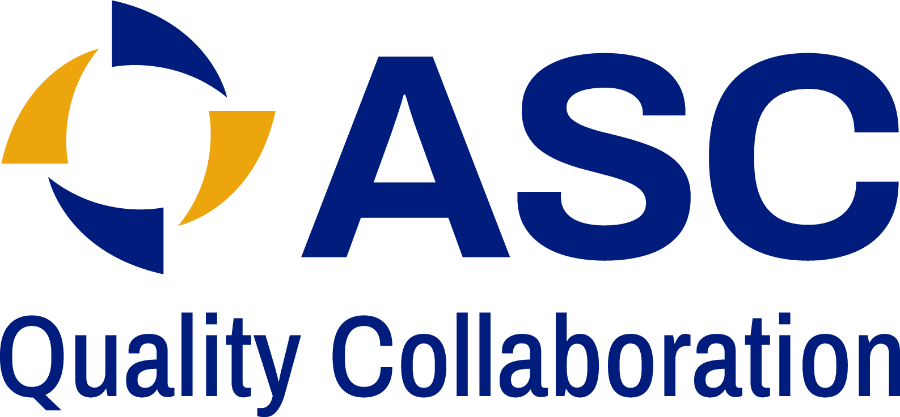

ATTESTATION

This attestation serves as a formal confirmation regarding the ASC Quality Collaboration Patient Safety and Quality Assessment Survey data and information for ____________________(Name of Center) submitted on (Date of Submission date) encompassing the time period of ______and _______.

Please attest to all statements before signing at the bottom of the form:

____Submission complete and accurate: I attest that the submitted data and information is accurate, reliable, and representative of the information collected during the specific time frame.

_____Participation in random validation process: I attest that I am aware of the random validation process utilized by the ASC Quality Collaboration, whereby a percentage of submissions are randomly selected to participate. If randomly selected, I agree to fully participate with the validation process which includes sharing of data and information, including but not limited to policies, procedures, and applicable meeting information. There are a total of 15 documents requested as part of the validation process. I acknowledge that non-participation in the validation process will result in exclusion from the ASC Patient Safety & Quality Assessment.

____If selected to be a part of the random validation process, I understand that the documents I submit to the ASC QC will remain confidential and that upon completion of the validation process, the ASC QC will destroy and not retain any documents provided.

____I attest that the CEO/Administrator of my organization concurs with the responses provided in the survey and of this submission.

_______________________________________________________________
Name of Individual Submitting which serves as my signature to the attestation.

Title of Individual Submitting: _________________________

